Ubuntu 20.04 OS installation.

Step1

Map/Mount the shared network drive which contains the OS iso images.

[\\10.157.255.17\data$](file:///\\10.157.255.17\data$)

Username – administrator

Password – Rjil@1234

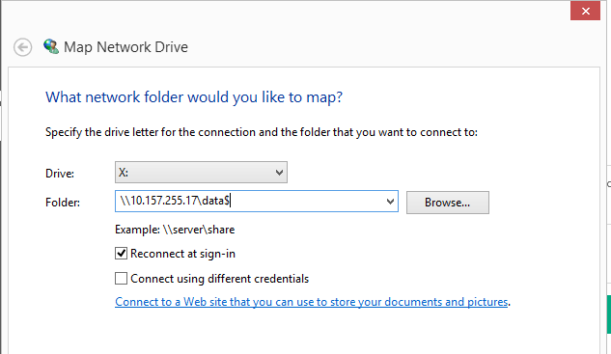

Step 2

Login to ILO using the credentials using the ILO ip shared. (use internet explorer)

Step 3

Use ILO console to install the OS. Use .NET console

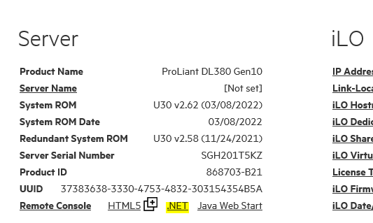

Step 4

Select the Virtual drive 🡪 Image File CD-ROM/DVD 🡪 choose the Ubuntu20.04 image iso from the mounted path in step 1.

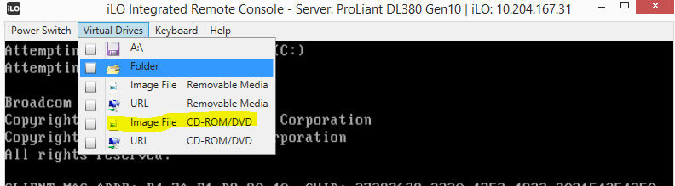

Step 4

Reboot the server (power switch – reset) 🡪 press F11 🡪 press 1 to select boot from CD-ROM

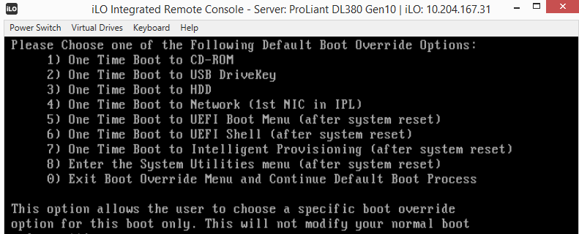

It will be checking the integrity and it will take some time

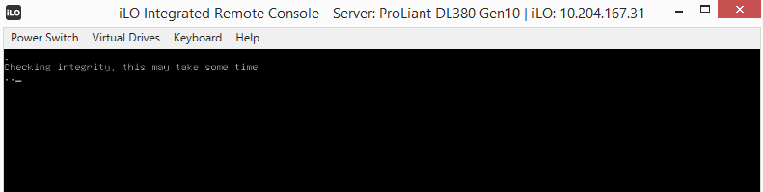

After integrity check follow the below instructions (select the required data and press enter for next step)

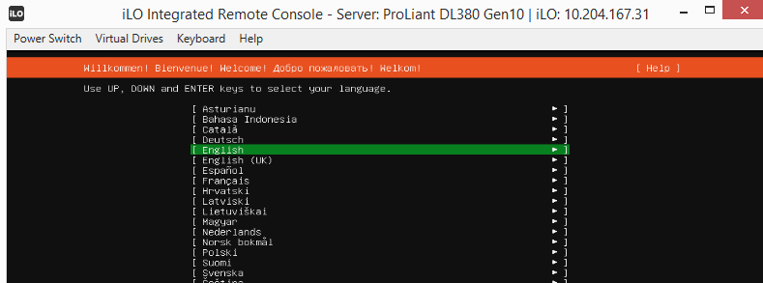

Select continue without networking

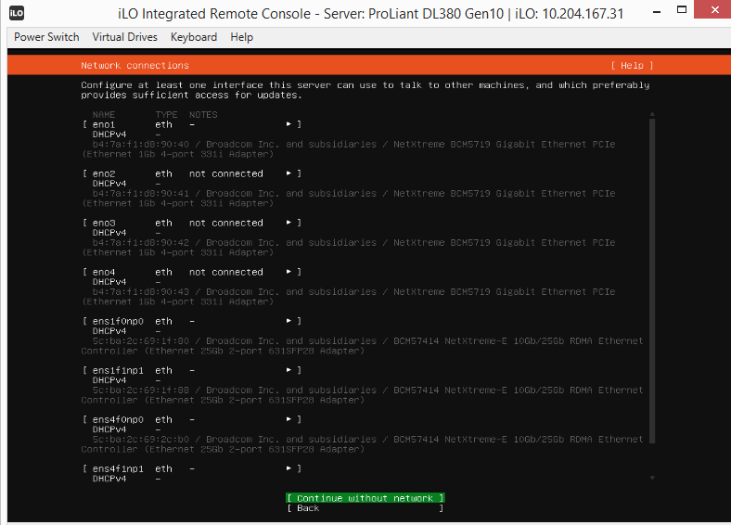

No need to add any proxy details, select done and continue until storage configuration

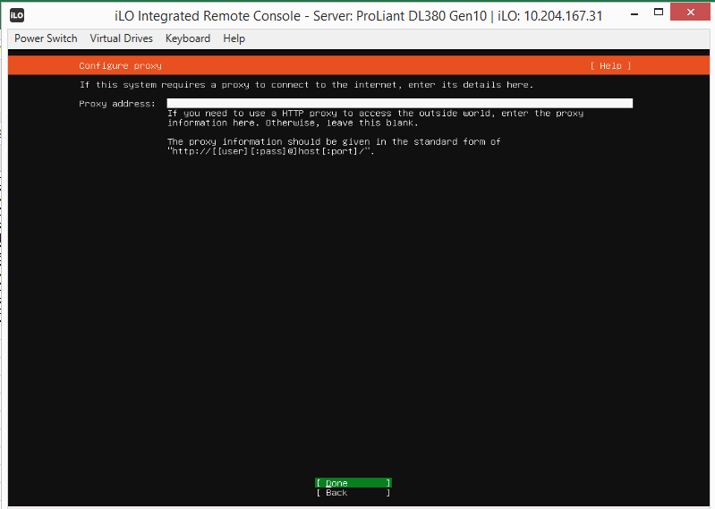

Select custom storage layout (use space bar for selection) and continue for the storage configuration

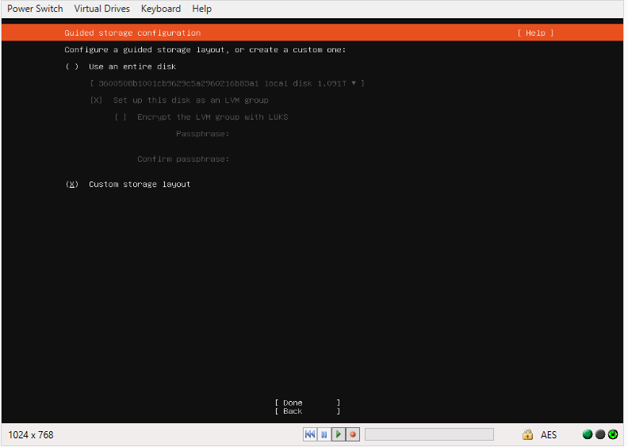

Select Raid1 device to use as boot device which is of 1.091 T storage.

And make required partition for root(/) and swap

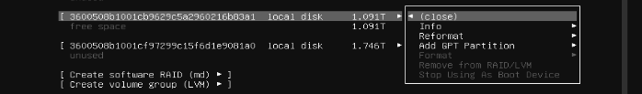

Add GPT partition 🡪 1T for root(/) and 93G for swap, continue the installation.

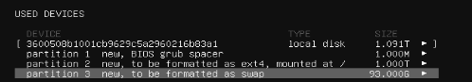

Fill required details server name, username and password as shared by team

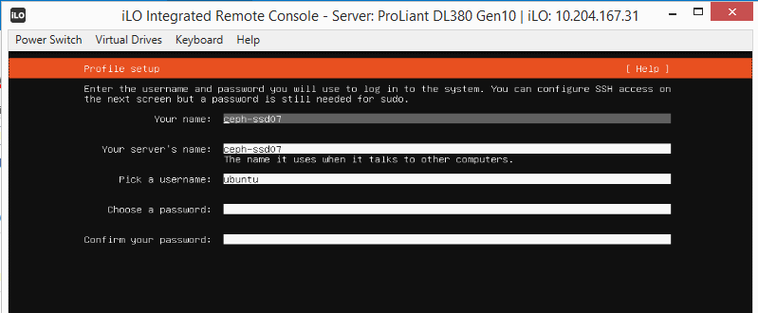

Select to install openssh and continue.

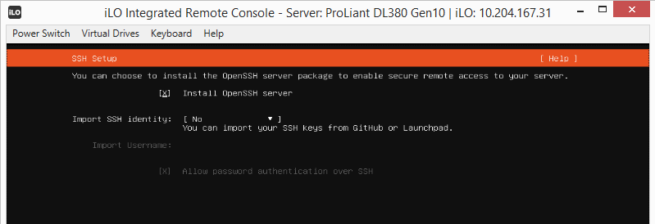

Reboot the device once installation done

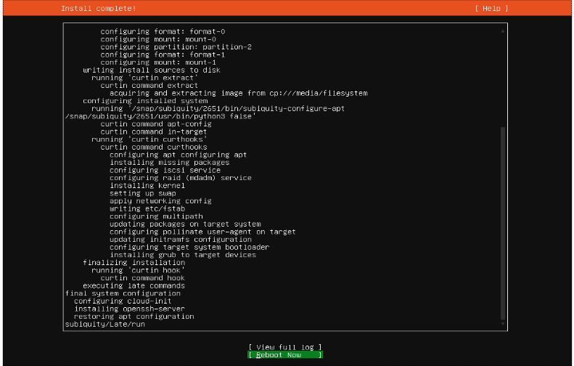

After reboot 🡪 wait for sometimes it will boot in to OS, verify after login in.